STUDENT Joseph Roper

SALFORD CITY COLLEGE | FUTURE SKILLS

BTEC National Extended Diploma in Creative Media Production

UNIT 6: CRITICAL APPROACHES

Unit 6 – Task 4

# Semiotic Analysis

Super Smash Bros is a game series produced by Nintendo, it is a fun family fighting game that has been enjoyed by many generations. On December 7th the new game of the series Super Smash Bros Ultimate was released and as you could imagine many fans were excited to play.

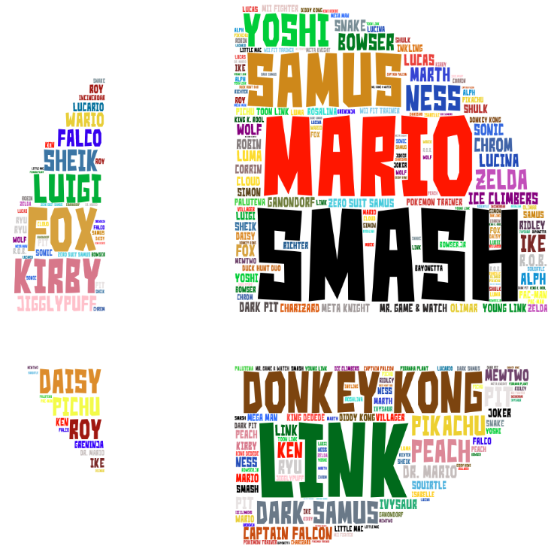

This word cloud is based off the game Super Smash Bros Ultimate which contains a collection of Nintendo characters and all-star characters from other game franchises such as Sonic and Pac-man. I believe this word cloud fits with the slogan of the new game which is “Everyone is here!” as it has the name of every single playable character placed in the word cloud. This word cloud is also great as each character’s name is represented by their related colour scheme.

# Content Analysis

|  |  |  |  |  |  |
| --- | --- | --- | --- | --- | --- |
| Game | Does it contain fighting? | Can you freely control your fighter? | Does it have Japanese culture? | Does it have a story mode? | Can you play online against other players? |
| Persona 5 | Yes, you fight demons based on Asian myths and you have an option to embed their power into your mask. | No, as your movement are restricted in the overworld you can only jump when you got to a ledge and in battle, you are stuck in place and can only choose from a selection of attacks. | Yes, as the game is based in Japan as you live the life of a Japanese student with an interesting after school life. | Yes, as the whole game is a fascinating story about a teenager who just wanted to go to school but ended up being wrapped up in world ending and reality breaking events. | No, as it is a single player game. |
| Pokémon | Yes, you must battle against other Pokémon with yours. | No, as your fighter has only 4 moves that you can choose to attack with. | It contains some Japanese myths. | Yes, as the game is mainly single player, but I believe people only play the games for the game mechanics such as catching Pokémon and battling with them. | Yes, you can battle with people from across the world with your Pokémon. |
| Mario & Luigi: Bowser's Inside Story | Yes, you fight enemies from the Mario franchise as both Mario and Luigi. | No, as you are restricted to set attacks such as throwing a green shell. | No, as the main character is an Italian plumber. | Yes, although it focuses more on gameplay. | No, the game is single player |
| Super Smash Bros Ultimate | Yes, as it is a fighting game. | Yes, you can control the character to do attacks precisely in real time and freely move around any level. | No | Yes, it has a detailed story mode that can be played for hours on end. | Yes, as a big part of the game is playing against other people online for glory. |

By doing this content analysis I have learnt that most games have a story mode although it may not be good or fully fleshed out it seems like a story needs to be tacked on for the game to sell. Although games with a good story mode really do make the difference and go the extra mile to heighten the player's experience. I have also learnt that most games contain aspects of fighting but usually don’t allow the fighter to freely move around.

# Cultural Context

## Genre

The Super Smash Bros games are a series of fighting games which in my opinion each get better every new entry in the series as Nintendo make a new game engine to make the fighting feel different from the last game. I personally really enjoy fighting games especially Super Smash Bros as you can play competitively or mess around with your friends and still have fun no matter what. Usually fighting games can only be competitively played online but recently the Super Smash Bros series has added different modes for online matches the main two are For Glory which is for competitive matchmaking and for fun it the online service then goes into a lot more subcategories. I believe this to be the best online service a fighting game has had as it caters to all audiences.

## Time Zone

The new game in the Smash Series Super Smash Bros ultimate released on Friday 7th at midnight during this hour millions of people waited up all night just to be able to play the game straight away as it released. Nintendo released the game at the same time for all countries, so it would be an equal start for every player. The game can be also played online in real time meaning you could play the game in the UK at 4 pm and battle someone in Australia which for them would be 2 am because of this you would usually battle people in the same country as you so it is the same time for both players to make it as fair as possible.

## Audience

I believe the Super Smash Bros series is tailored to be playable by the whole family as it has a massive character roster that anyone can find a favourite character in. As if a boy wanted to play they would probably pick someone from the Mario or Zelda franchise as that is probably the games they have played beforehand. If a girl wanted to play they would probably pick one of the princesses like Princess Peach, Daisy and Zelda as girls love pink and purple colours and princesses as that's the media they usually consume with Disney Movies like Frozen and Tangled. If a teenager was to pick a character they might choose someone from the fire emblem cast as they all wield swords and come from more mature games compared to Kirby. If an adult was to play the game they might pick one of the retro characters like Duck Hunt or Pac-Man as that is the games, they played in their childhood. I believe most of the players for this game rather live in Japan or English-speaking countries as all the marketing is rather in English or Japanese meaning that you’ll only find out about the game if you're rather a massive fan of Nintendo or you see an advert in one of those countries.

I think the socio-economic status of the players is middle class to upper class as to play the game which was released at the price of £50 you also have to own the Nintendo Switch which is roughly £350 brand new, meaning people without money won’t want to spend money on a console with only a few good games and which doesn’t really receive many good 3rd party games as most companies don’t want to spend time to optimize their games so they can be played on the Switch

As Super Smash Brothers is meant to be a family game it should cover all of the gaming psychographics to appeal to the whole “family” which I think it does as it obvious covers action and achievement because it is a fighting game meaning the goal is to win (Achievement) by beating up your opponent through punches kicks and explosions (Action). It also covers social as you can play against your friends and mastery as it can be a competitive game by going to competitions to win money which you will need to practice a lot for. Finally, it covers creativity as the game is about getting characters from different games and finding out who will win in a fight and lastly immersion as you get to play as someone else and as in Super Smash Brothers Brawl there was a really good story mode.

## Location

Super Smash Bros is enjoyed worldwide as it caters to many audiences with its flagship cast of characters as I believe everyone has heard of and likes the Mario and Pokémon franchise. The series is mainly enjoyed in the west as England and America seem to love the fighting game genre although in competitive play many pro players come from around the globe to take part in American competitions as there is always someone practising with an unorthodox fighter from the bottom of the tier list to show their true potential. For example, the Mexican pro player who started winning matches with Pac-Man who was at the known as one of the worst fighters in Smash.

[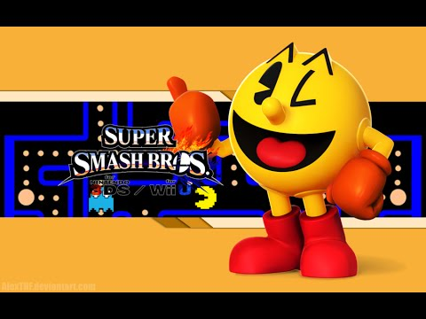](https://www.youtube.com/watch?v=ZAeADNmt05U)

## Device

Since the Smash series is owned by Nintendo the games are only released on Nintendo branded consoles meaning there has only ever been one version of each game. I believe this also makes the game even more fair across the board as with over games that are released cross-platform you have people saying things like the PC version is Superior as more processing power can be used to make the game run smoother and faster than if the game was played on a phone meaning if someone playing the game on their phone went against someone on the computer the PC user would be at a clear advantage. Therefore, because the game is only released on one Nintendo console everyone is equal in terms of computing power. The current game in the series was released on the Nintendo Switch which is a system that can be portable meaning you can play the game wherever you like, however it can also act as a home console connected to a tv meaning the Nintendo Switch caters to all audiences those who want portability and those who want a regular home console.

[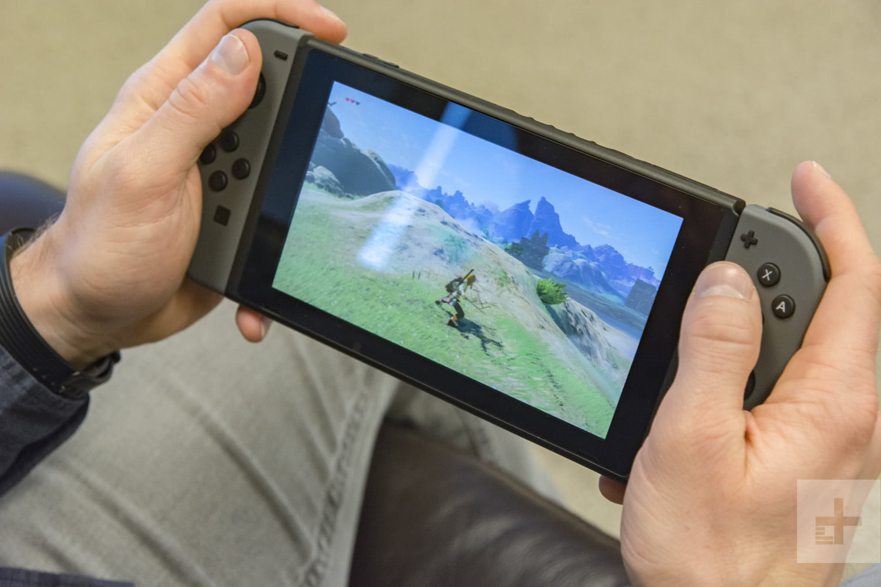](https://www.digitaltrends.com/video-game-system-reviews/nintendo-switch-review/)[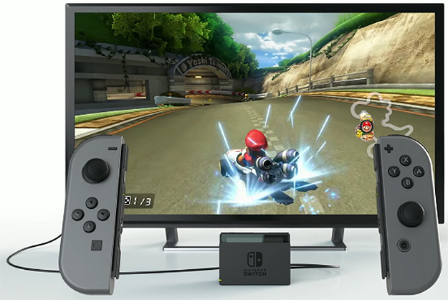](https://hothardware.com/news/nintendo-switch-joy-con-controllers-detailed-in-new-video)

# Narrative Context

## Tie-in Stories

The Smash Bros games containing a lot of assets from other games that tie into the new one, for example, one of the items in the game is a Poke ball, and if you pick it up and throw it a Pokémon from the famous game series will pop out and help you battle. There are countless other items and enemies that come from other games bringing their story with them as you can view each item in the gallery and read which game it comes from, what it does and the story behind it. Even each map represents the game series it's from some maps will even have hazards where a well-known boss from the game will appear on the map which you have to fight. Each character from a different game series will also bring some of the game with it as the developers try to make it so each character encompasses the game it is from, a Youtuber called RelaxAlax made a career out of analysing characters move sets and saying which game each move came from and the backstory behind it. For example, in the previous Smash game the characters Link was able to throw bombs which were out of the game Twilight Princess but now in the new Super Smash Brothers Ultimate Link throws bombs from his new game Breath of the Wild.

[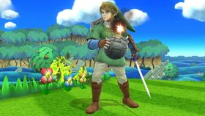](https://www.mariowiki.com/Link)[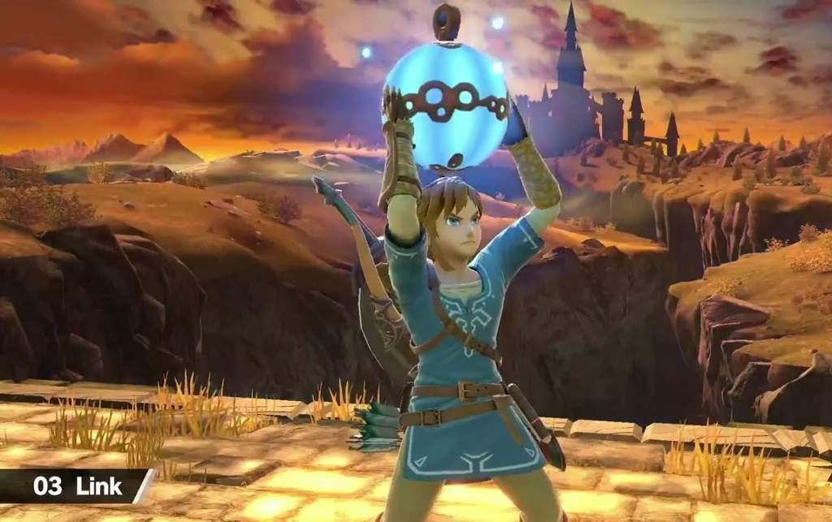](https://aminoapps.com/c/smash/page/blog/super-smash-ultimate-link/qZfR_unMqpGYLnWknLnEWpdbn240K7)

## Fandoms

The Super Smash Bros series has a huge fan following with each new game. The developers love this and work together with the fans to make the game more fun for everyone, this could be voting to see which new character they want in the game or it can be helping the developers make the game more refined by stating if there are any glitches in the game that need to be fixed. Fans will also tell the developers when a character needs to be balanced to match the over characters fighting the power. Most of the fan following for the game comes from competitive play as fighting games are built for being in tournaments where you fight to see who the strongest player is. There is still a massive fan following for the game Super Smash Bros melee which is 17 years old almost 18, this game has only been kept alive by competitive players as Nintendo have stopped development for this game and no longer update it, the game is still played regularly at competitions and some people even make a living off the prize money for these while also streaming them practising the game and receiving donation from their fans.

[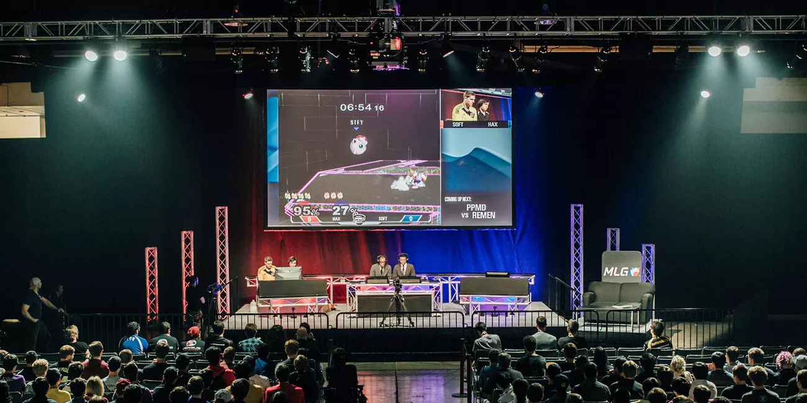](https://www.inverse.com/article/26641-nintendo-esports-nintendo-switch)

## Reputation

The reputation this game series holds is too hard to imagine as the creators of the game must equally represent every fighter no matter their popularity. As if the game ruins the reputation of any of the fighters from the other games series they would probably be punished and sued so much they would never be able to work in the industry again, as if they show a character like Mario or Pac-man doing something against the respected companies wishes, for example, a childhood hero smoking it would ruin the reputation of the brand forever. The game also has a big reputation as it is produced by Nintendo and one of their greatest console sellers meaning that if one of the new games turned out to be terrible it would have disappointed millions of fans and probably have made people in the company lose their jobs and some professional players jobs.

## Timeline

Every game in the Smash series follows a timeline as with each new game more characters are added in the reveal trailers of these characters for the Wii U version of the game characters would receive invitation letters to fight in Smash. However now with the new game, it seems like they are abducting players from different games to fight against. In each game, there is a looming threat of 2 bosses one called the master hand and crazy hand but in this new game, you must work together with these bosses to fight a bigger threat.

[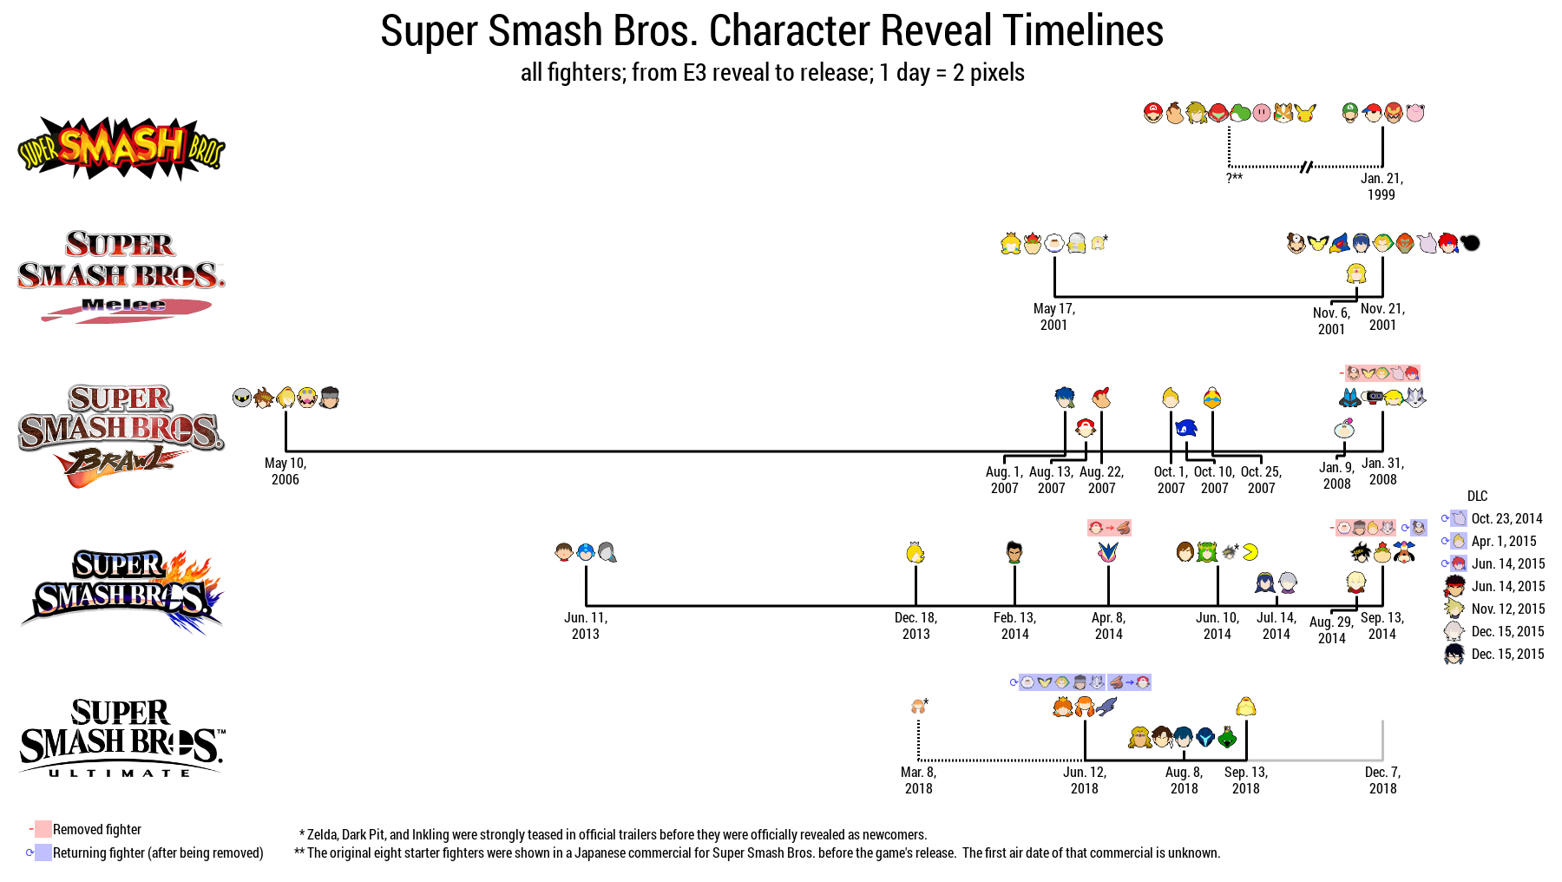](https://www.reddit.com/r/smashbros/comments/9fsx86/allfighter_toscale_reveal_timeline_updated_to/)